Homework 3
- Complex Impedance
We derived a capacitor’s complex impedance $Z_{C}=\frac{1}{Cωj}$ in class. Find the amplitude of the capacitor’s impedance $X_{C}$, and replace $ω$ with $f$.
(5)
- $X_{C}$ is called reactance. Show your work below:

- RC circuit
- Simulate the circuit below, add voltage meters at VA and VB.
Insert your simulation here with VA VB values: (5)
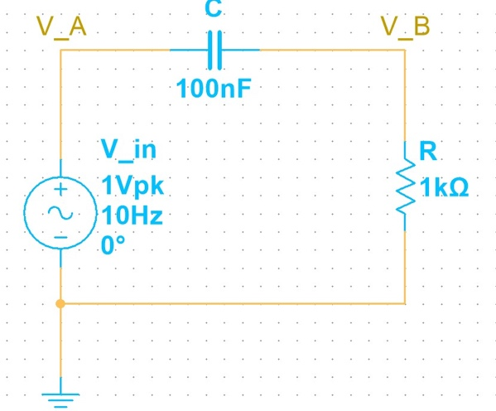
- Fill the table below: (8) ($V_{A}$ is $V_{in_peak}=1V$ and it shouldn’t change. $V_{peak}=1V$ is equivalent to $V_{peak to peak}=2V$)
input frequency Hz | Calculated |  |  | Multisim
10 | Xc $Ω$ | VB (V) | VA-VB (V) | VB (V) | VA-VB (V)
100
500
1k
1.2k
1.3k
1.4k
1.5k
1550
1585
1600
1.7k
5k
10k
100k
(2) show your work for $f=500Hz$
- Filters
  - The RC circuit we just built, is it a high pass filter or low pass filter?
(2)
  - Derive the $V_{out}$ formula for this filter and calculate the value at 500Hz. Does it agree with your table on page 2? Is $V_{B}=V_{out}$?
(10)
  - Derive the phase angle formula for this filter and calculate the value at 500Hz.
(8)
- [Design Exercise] Cutoff frequency $f_{c}$
  - Design a new RC filter. Make sure its cutoff frequency is in the range of 100Hz to 1500Hz. Simulate this circuit’s output and input voltage. Click “Split” in Multisim, click run (the green triangle). Two sine waves will appear on your screen. Adjust the input frequency from 10 Hz to 50kHz. Observe the waves. Does the wave graph on the right of your screen agree with the numerical values showing on the meters* on the left side of your screen? Now set the input frequency at $f_{c}$.
(10) Insert your new RC filter’s schematic /graph split view screen shot here. Set input frequency at $f_{c}$. Make sure both of the input and output sine waves are visible on the screen.
*Note: Double click the voltage meter, on the right edge of your screen, check the box of “Periodic” in the “Interactive simulation” item. Now you will be able to see the peak values of VA and VB as you slide though different input frequencies.
  - Derive the cutoff frequency formula and calculate your filter circuit’s $f_{c}$, voltage gain $A_{v}$at $f_{c}$, and phase angle $φ$ at $f_{c}$.
Show your calculation here. Compare your results with your simulation above. Move your mouse to the two (most likely one green one blue) sine waves or use cursors and find the two waves peak values and the phase angle. Do the measurements agree with your calculation? Is your filter a high pass filter or low pass filter? (10)

  - Make a Bode plot of this circuit, that is, the decibel voltage gain $A_{v(dB)}$ as a function of frequency $f$ in Hz. Mark your $f_{c}$ in your Bode plot. Is it at $-3dB$?
(10) You may set the x-axis (f(Hz)) in the range of $0\sim {10}^{5}Hz$. Here on our website you will find my examples of plotting in Python and Dr. Mikhailov’s plotting code in MATLAB. Mathematica can also do this job well.

